Combined Heat and Power

Jan Doskočil, Martina Haindl

Co-operating Universities



Financial support by

Prague and Vienna, 2010

Table of Content
Table of Content 2
1. Introduction 3
2. Combined production of electricity and heat 4
2.1 The concept of cogeneration 5
2.2 Heat consumption 7
3. Division of cogeneration units 8
3.1 Advantages and disadvantages of cogeneration units 9
3.2 Application of cogeneration units 10
4. Cogeneration in the czech republic 11
4.1 Cogeneration in austria 13
5. Trigeneration……………………………………………………………………………..…..…15
6. Conclusion…………………………………………………………………………………...….16

Introduction

One of the largest sources of CO2 generation is energy production. In Austria, power generation produced 46% of total Carbon emissions in 2007 (1). In whole Europe energy use without transportation accounts for about 60,4 % of Carbon emissions, followed by Transportation with 19,3% in 2006 as can be seen in Figure 1.
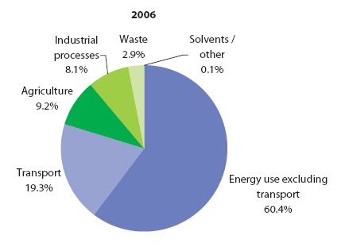
Figure No.1: CO₂ emissions in EU27 member states by sectors (2)

Different ressources for generating electricity are responsible for different levels of CO2 emissions. For example, every kWh that is generated by coal- fired centralised electricity generation plants equals 1 kg of CO2, according to the Commonwealth Scientific and Industrial Research Organisation (CSIRO) (3). Table 1 shows the amount of CO2 emissions produced by different fuels for every GWh of electricity supplied. Therefore, the total amount of CO2 emissions produces by electricity generation depends on the fuel used.
Fuel | Emissions (tonnes of CO₂ per gigawatt hour electricity supplied₎
Coal | 242,9
Oil | 166,0
Gas | 101,6
All fossil fuels | 165,6
All fuels (including nuclear and renewables) | 124,1
Table No. 1: CO₂ emissions from different fuel sources used in electricity generation (UK)(3)

To sustainably reduce Carbon emissions, countries have set goals to achieve CO₂ reductions. Various methods and strategies are existing to achieve these goals.
- Switching to renewable ressources that generate electricity with lower CO₂ emissions than fossil fuels, as can be seen in Figure 2.
- Using lower carbon emitting fuels like gas instead of coal.
- Installing carbon sequestration, a method to collect and store CO₂ in order to prevent it from emitting into the atmosphere.
- Implementing technologies to cut down energy required to produce like energy conservation. In detail it means that customers buy energy for its ability rather than for the energy itself.
- Another possible strategy is to force cogeneration technologies that support the efficient use of energy. These often also called combined heat and power generations need less fuel to produce the same amount of energy and therefore fewer emissions are emitted (3).
Studies have shown that cogeneration is the most cost- effective way to reduce CO₂ emissions. Some of the facts leading to this statement are listed in the following paragraphs.

2. Combined production of electricity and heat

The concept of cogeneration of electricity and heat (CHP) in the Czech Republic is also known as heating industry. In recent years, the word cogeneration got more common, taken from the English word co-generation. In German the description „Kraft Wärme Kopplung“ is used (5). Cogeneration is based on the principle of simultainously producing electricity, thermal energy and even sometimes mechanical energy in one power plant. Electricity is considered as the highest form of energy and can be universally used. Ideally, electricity can be changed into any other form of energy without any losses (mechanical, thermal, etc.). In contraty, heat is a less valuable form of energy and is often occuring as a waste product when energy is produced. The transformation of heat into optimal forms of energy is more difficult and may be done only partially. Conversely obtaining heat energy from the PES in the form of hot or warm water is relatively cheap and easy (6).

2.1 The concept of cogeneration

Cogeneration is the process of energy conversion from different kinds of fuels. First, high-potential heat energy is used to perform work and then the lower temperatur occuring during the same process is used to cover the leeds of heat demand. The main advantage of cogeneration is a high utilization rate of primary energy sources in connection with the separated electricity and heat production. Conventional fossil power plants are producing a big amoutn of heat as waste product. Cogeneration plants are using this heat to produce electricity and heat at the same time and therefore reach more energy efficiency. The Efficiency of separated production of electricity is considered 35% (condensing power) and 85% heat (gas heat). By combined electric and heat energy production electrical efficiency reaches about 30% electric energy efficiency and about 50% heat efficiency. Therefore, the overall efficiency is around 80% - 90%. Higher efficiency reduces the consumption of primary energy sources, and therefore even reduces the impact of the power plant on the surrounding environment (7). The principle is shown in figure No.2.

power
production
heat
production
combined heat
and power

heat energy
50
electric energy
30
heat energy
85
electric energy
35
fuel
100
fuel
100
fuel
100

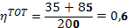

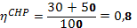

Figure No.2: Combined heat and power production (7)

Figure No. 3 illustrates the energy flow in cogeneration power plants and conventional power plants. The big difference between these two is tha with cogeneration it is possible to produce heat and electrical energy with a single device rather than by two seperate plants (power plant and heat plant) that transport high efficiency losses. The examples in Figure 3 use the numbers given in Figure 2 to demonstrate the differencies in GJ.

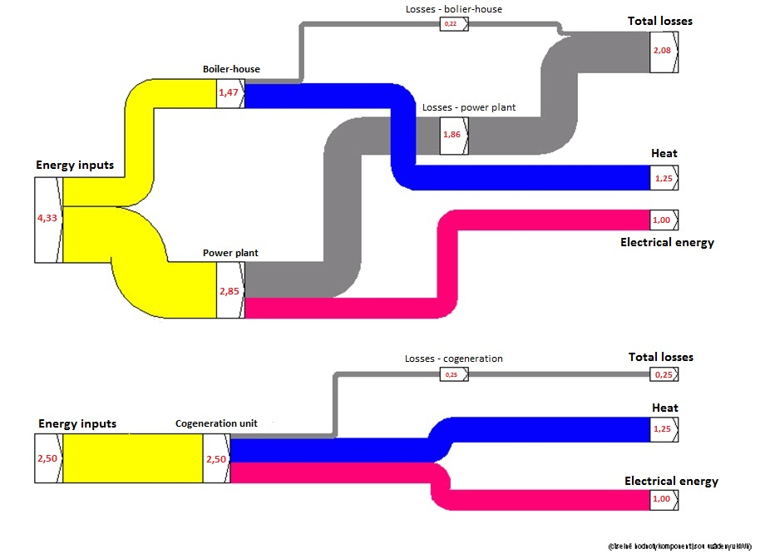
Figure No.3: Energy flow diagram for the classical seperate production of heat and electricity and energy production in the cogenertaion unit (5)

In detail, Figure No.3 demonstrates that the separated production of heat and electric energy needs about 1.17 GJ to deliver 1 GJ of heat and about 1.83 GJ to produce 0,18 GJ of electrical energy with a total loss amount of 1,37 GJ. While cogeneration plants only need a total of 2 GJ to produce the same amount of heat and electricity and therefore the losses are only 0,4 GJ. This example shows that you can have significant savings in primary energy sources when cogeneration is used and therefore, negative environmental impacts are reduced as well (5).

Additionally, cogeneration power plants are usually smaller than conventional power plants even though they are producing a similar output and generally are located decentralised, in a low distance from the end user. These structures resut in the minimization of transmission losses. On average, transmission of electricity is linked with an energy loss of 12 percent over long distances. Since cogeneration plants are usually located in the same area where the final consumption happens, these losses are rarely emerging (3).

2.2 Heat consumption

Heat is the considered main product when it comes to combined heat and power production, power supply is the secondary product.

When cogeneration units are only used for power generation, their operation is not profitable because everything is subordinated to necessary production of heat, namely the actual design and the operation units. Heat supply from centralized cogeneration units can be divided into heat supply for heating up buildings and heat necessary for the preparation of warm utility water. Consumption of heat for heating buildings is dependent on the outside air temperature, while the heat needed for warm utility water preparation is not dependent on the temerature outside. Heat supplied to customers can be further divided into:
•heat for heating up residential buildings
• the heat required for heating up water in residential buildings
• heating of non- residential buildings
When designing cogeneration units, the annual heat consumption must be taken into account. These heat consumptions can be displayed through time diagrams that show heat curves, which can be divided into daily, monthly and yearly periods. Therefore, these heat diagrams are an important factor when designing a cogeneration unit. Mainly, daily and yearly charts are used for sizing the cogeneration plants. Precisely, by designing a cogeneration unit, emphasis is put on the highest annual usage of maximum power cogeneration units. It is neccessary to note that cogeneration units can not be operated without cutting-edge recources and storage containers for profitable operation. Storage tanks are used for storing heat energy when there is no current heat supply neccessary, but there is demand on electricity. Heat energy is collected from the accumulation tank at a time when the cogeneration unit is in operation, which is demonstrated in Figure 4.
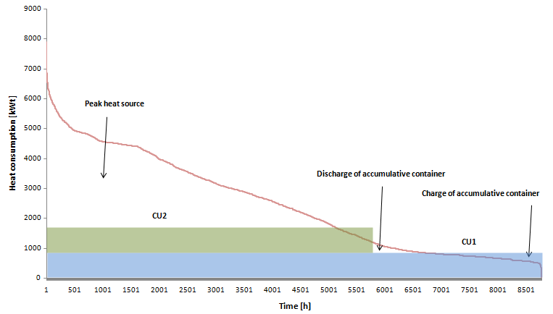
Figure No.4: Diagram of annual heat consumption

Figure No. 4 represents an Annual diagram of a heat consumption system of CSH. The final consumers are residential buildings and therefore the heat demand in the warm season is declining and is intended only for water heating. The installation of a cogeneration unit is largely dependent on the type of heat consumers. Consumption diagrams of heat and electricity look different for the industrial and the housing sector. The important difference is that electricity needs of end consumers are different and therefore also the proposals of cogeneration units. It is possible that the cogeneration units cover the total consumption of electricity and furthermore generated surpluses of electricity can be sold at fixed price to the distribution network. Furthermore, if the operation of the unit should be profitable, time use of rated output CU should not fall below 3000 hours (6) as you can see in Figure No. 4 .

3. Division of cogeneration units

Cogeneration units can be diveded accordingly to many different aspects. CHP units can be classified by the types of technologies used, kinds of fuel used (renewable, non-renewable resources), the maximum available output (micro-cogeneration, mini-cogeneration, cogeneration of small, medium and large power), or by type of usage (primary, peak, backup, reserve). Table 2 presents a brief overview of cogeneration units divided by their technology. It shows the power range and fuel types used by different types of CHP units. Furthermore, it demonstrates that units with big output can supply the heat in high potential form. We will not describe the priciples of CU in detail due to the compact length of the paper.
Drive unit | Fuel | Power range [MWe] | Heating production electricity production | Electric effiency [%] | Total effiency [ %] | Form of heat
Bleeder steam turbine | any | 5 - 300 | 0,2 - 0,4 | 10 - 30 | 78 - 88 | LP steam, hot water
Back-pressure steam turbine | any | 0,1 - 100 | 0,1 - 0,4 | 7 -20 | 75 - 88 | LP steam, hot water
Combustion turbine | natural gas, light fuel oil, biogas, products of gasification | 1*) - 250 | 0,4 - 1,2 | 25 - 48 | 75 - 90 | hot water, warm water, LP steam, HP steam
Steam - gas device | natural gas, light fuel oil, biogas, products of gasification | 10 - 400 | 0,8 - 2,0 | 35 - 60 | 85 - 90 | hot water, warm water, LP steam, HP stem
Combustion engine | natural gas, light fuel oil, biogas, products of gasification | 0,01 - 10 | 0,5 - 1,1 | 25 - 45 | 75 - 92 | hot water, warm water, LP steam
Steam engine | biofuel | 0,02 - 1 | 0,1 - 0,3 | 10 - 25 | 70 - 80 | warm water
Stirling engine | natural gas, biofuel | 0,001 - 1 | 0,3 - 0,7 | 20 -40 | 70 - 85 | warm water
Fuel elements | biomass, coal, metanol, natural gas | 0,04 - 0,5 | 0,8 - 1,0 | 37 - 45 | 85 - 90 | warm water hot water
Table No.2: Classification of Cogeneration units (6)

3.1 Advantages and disadvantages of cogeneration units

Using the method of CHP, fuel savings of about 40% of heat and electricity production are possible. This fact also causes important cost savings of around 60% of end users. In other words, for the same amount of fuel input we get approximately twice the amount of energy output. Part of the energy produced by cogenerations can be sold to the energy grid and therefore, costs be can further reduced. Another advantage resulting from fuel savings is a positive environmental impact due to the reduction of CO₂ emissions. Furthermore, cogeneration units are usually placed close to the end consumers and therefore, distribution losses of electricity and heat are reduced.
The main disadvantages of CHP are higher initial investment costs. To ensure the profitability of cogenerating units, heat and electricity must be produced and used simultaneously. Furthermore, it is important to note that CHP units are producing a noticeable amount of noise. This fact must be considered in planning the facility especially when it is located in a residential area where noise reductions are neccessary. Due to this fact, higher costs of investments will occur and cogeneration units may not be able to run during night hours. Advantages and disadvantages of single type CUs are presented in the table below.
Drive unit | Advantages | Disadvantages
Steam turbine | wide range of fuel usage; high efficiency; long lifetime; large power range | high cost of investment; slow start
Gas turbine | wide range of fuel usage; high reliability; allowing longtime uninterrupted operation; relatively low cost of investment | small number of producing output (range); slow start; fuels have to be clean and dry; noisy
Combustion engine | wide range of fuel usage; high efficiency; relatively low cost of investment; quick start | needs cooling if heat is not used; backup needed if electricity and heat is not consumed; high low-frequency noise
Stirling engine | production of electricity not depend on production of heat; low emissions | low mechanical effeciency; meanwhile high investment costs
Fuel elements | low noise; low emissions; high efficency; short time of build up | cost of investments; short lifetime; long start time
Table No.3: Advantages and disadvantage of single type CUs (7)

3.2 Application of cogeneration units

Cogeneration units can be used almost everywhere, where heat and electricity are needed. Large cogeneration devices (steam, gas turbine) are used in CHP plants that supply heat to the centralized heat supply systems and electricity supply to the electrical power network. These big cogeneration devices often serve as backup power sources. As mentioned above, the consumption of heat and electricity is different depending to the consumer needs. Therefore, bigger CHP plants must be accompanied with heat accumulation tanks, where heat is stored when demand for electricity exceeds heat demand.
Micro and mini CHP units are used for smaller applications. For example in hotels, hospitals and swimming pools, where a stable demand for heat supply is given. Surplus electric energy producers can sell energy to the public distribution system (through contracts with distribution companies).

4. Cogeneration in the czech republic

Table No.4 shows the division of fuels according to CHP in the Czech Republic. Installed capacities of production of electricity, heat, etc. are divided by type of fuels used in those equipments. The figures also include data of companies that generate electricity in CHP and heat only for their own consumption. The table includes all types of CHP (Combustion turbine, back pressure turbine, bleeder steam turbine, micro-turbine, combustion engine, stirling engine, etc.), of small enforcement of the kW to large - ten and hundreds of MW. The column inputs include the quantity of fuel in cogeneration units. It is necessary to mention that it is a problem to determine exact numbers for combusting biomass in cogeneration units because biomass is often burned with non-renewable resources like coal. Therefore, coal has a major share of energy production in on power units. This is the reason why there are no numbers listed for biomass in table 4. Because of this fact, it is assumed that the production of electricity from biomass is highly undervalued.
Table No.4: Division CHP by fuels in the Czech Republic in 2008 (8)
Fuel | Number  of companies | Number of devices | Electrical output [MW] | Heating output [MW] | Electricity production [GWh] | Heat production [TJ] | Stock | Unit
Brown coal | 39 | 109 | 7 133 | 21 197 | 6 159 | 69 072 | 9 114 | 10³. t
Black coal | 14 | 31 | 1 998 | 5 613 | 2 639 | 25 410 | 2 122 | 10³. t
Fuel oils | 15 | 16 | 193 | 924 | 168 | 4 012 | 127 | 10³. t
Biomass | 16 | - | - | - | 192 | 3 888 | 726 | 10³. t
Waste | 3 | 3 | 3 | 32 | 19 | 746 | 94 | 10³. t
Liquid fuels | 2 | 2 | 9 | 79 | 5 | 188 | 6 | 10³. t
Natural Gas | 152 | 429 | 614 | 2 439 | 952 | 10 348 | 4 713 | GWh
Biogas | 81 | 183 | 49 | 63 | 138 | 789 | 84 | 10⁶ m³
Other gaseous fuels | 11 | 27 | 175 | 314 | 1 098 | 8 646 | 3 969 | 10⁶ m³
Waste heat | 3 | 3 | 9 | 24 | 36 | 356 | 900 | TJ
Total | - | 803 | 10 182 | 30 684 | 11 406 | 123 455 | 228 419 | TJ

Table No. 5 shows the production of electricity and heat in cogeneration units, divided by the types of fuels used. The shares are given and show how cogeneration production takes part on heat and elektricity producion. However, it does not show the share of the total elektricity production in 2008, that was 83 517 GWh, but only the share of elektricity production on those gi. If the CHP production of elektricity and heat was applied to the total elektricity generation, than nuclear, hydro, wind power and others would have a total electrcity production of cogeneration of 13,7% (for the fuels listed in the table, this percentage is 21%). The table also shows that cogeneration has a significant proportion of the total heat production in the Czech Republic of about 39%.

Fuel | Electricity production Total [GWh] | Electricity production made of CHP [GWh] | Share of electrcity made of CHP [%] | Heat Production [TJ] | Heat production made of CHP [TJ] | Share of heat made of CHP [%]
Brown coal | 42 347 | 6 159 | 15% | 91 064 | 69 072 | 76%
Black coal | 5 885 | 2 639 | 45% | 31 182 | 25 410 | 81%
Fuel oils | 229 | 168 | 73% | 13 134 | 4 012 | 31%
Biomass | 1 171 | 192 | 16% | 15 514 | 3 888 | 25%
Waste | 19 | 19 | 100% | 3 923 | 746 | 19%
Liquid fuels | 5 | 5 | 100% | 5 394 | 188 | 3%
Natural Gas | 1 112 | 952 | 86% | 128 380 | 10 348 | 8%
Biogas | 267 | 138 | 52% | 1 002 | 789 | 79%
Other gaseous fuels | 3 227 | 1 098 | 34% | 18 665 | 8 646 | 46%
Waste heat | 36 | 36 | 100% | 8 649 | 356 | 4%
Total | 54 298 | 11 406 | 21% | 316 905 | 123 455 | 39%
Table No.5: Share of electricity and heat production made of CHP in the Czech Republic in 2008 (8)
Figure No 5. and No 6. show to what extent the CHP production involve various types of fuels. From the graph it is clear that the biggest shares are from black and brown coal, which is burnt in large thermal power plants or where possible, combined with burnining biomass. In recent years, the trend of constructing smaller CHP units that supply heat to a smaller systém of centralized heating supply and burn natural gas has increased (8).
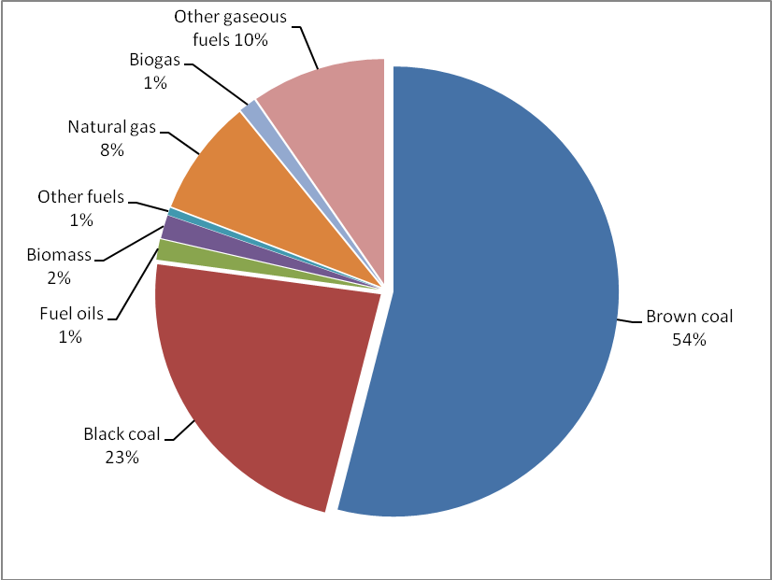
Figure No.5: Share of fuels on electricity production made of CHP in 2008(8)

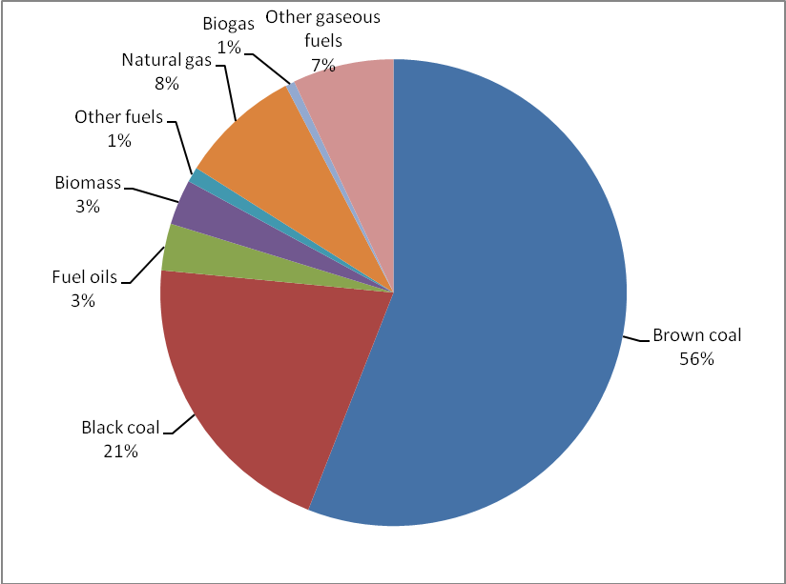
Figure No.6: Share of fuels on heat production made of CHP in 2008(8)

4.1 Cogeneration in Austria

In 2008, Austria's total heat and electricity production was 67.000 GWh. 24.380 GWh were produced in heat plants and 18.559 GWh from that were produced through cogeneration units. The total share share of electricity and heat produced from cogeneration plants in Austria is around 28% (12).

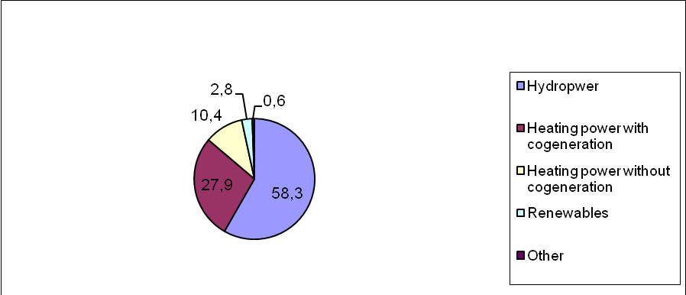
Figure No.7: Share of Electricity production in Cogeneration units in Austria (12)

Fuel | Electricity production made of CU [GWh] | Heat production made of CU [GWh] | Electricity production made of CU [TJ] | Heat production made of CU [TJ] | Total Electricity and heat production of CU [GWh]
Fossil | 14.838 | 16.123 | 53.418 | 58.044 | 30.961
Biomass | 2.162 | 5.036 | 7.782 | 18.131 | 7.198
Other | 1.559 | 5.605 | 5.613 | 20.177 | 7.164
Total | 18.559 | 26.764 | 66.812 | 96.352 | 45.323
Table No 6 shows the division of fuels according to cogeneration in Austria. Fossil ressources are delivering the biggest amount of heat and electricity with an amount of 30 961 GWh in 2008. Biomass and all other ressources like waste are appoximately producing the same amount of energy output in Austria.

Table No.6: Electricity and heat production made of Cogeneratio units in Austria in 2008 (13)

Table No 7 lists the different fuels used in austria for cogeneration and their share on electricity and heat production. In Austria, the most important fuel for cogeneration units is natural gas with a share of about 50%. The other halfe is produced through biomass, oil, hard coal, waste and coal gases.

Fuel | Electricity production made of CHP [TJ] | Heat production made of CHP [TJ] | Overall energy out of CHP [TJ]
Natural gas | 24.986 | 21.413 | 46.399
Biomass | 7.163 | 14.278 | 21.441
Oil | 2.633 | 4.235 | 6.869
Hard coal | 1.473 | 2.974 | 4.448
Waste | 1.005 | 2.648 | 3.653
Coal gases | 350 | 392 | 743
Brown coal (lignite) | 0 | 0 | 0
Total | 37.610 | 45.941 | 83.552
Table No.7: Division of cogeneration units by fuels in Austria in 2008 (14)

Trigeneration

The limiting factor in designing a CU is the consumption of heat during the summer months. Partially, this problem can be solved by using CU in combination with cooling absorption unit. This could be air conditioning in for example residenial buildings, offices or industrial buildings. The technology that can combine the production of electricity, heat and cooling is called trigeneration. Trigeneration is advantageous in terms of operation time. Therefore, the cogeneration unit can operate more efficiently during hot seasons, when the demand for heating is low. Using cogeneration in combination with absorption cooling device significantly increase the annual effective operation of the unit. The big advantage of absorption cooling is the replacement of electrical energy input (used for refrigeration compressor) with heating energy. Other advantages are the simplicity, reliability and quiet operation of the unit. Disadvantages are high investment costs compared to the compressor units of refrigeration and a larger size of the unit. Capital intensive trigeneration is proposed to cover basic consumption (electricity, heat, cold). To cover the peaks, it is cheaper to deploy technology investment (boiler, compressor cooling equipment, electricity from the network)(16).

Conclusion

The topic of cogeneration has a big significance regarding energy decisions of the future because of the mentioned facts like scarcity of fossil ressources, rising CO2 emissions and the related neccessity of efficient energy use. Besides the environmental reasons, cogeneration is also advantageous in energy cost reductions because of less overall energy needs and the beneficial fact of selling surpluses to energy grids.

Besides the advantages, this technology also carries some disadvantages that need to be considered carefully like the higher investment costs and the constant precondition of a heat and electricity demand. Therefore, the future developments will be towards mini and micro cogenerations in decentralised energy systems.

However, there is still a huge lack of knowledge about the high diversity of using cogeneration units. The International Energy agency published a study listing the significant additional potential of cogeneration technology in future. According to this scenario, there is a significant additional potential visible till 2030 as shown in Figure number 8 (15).
Figure No.8: CHP Potentials (14)

The official future trend of cogeneration in Austria is stated in the Eco- Electricity paper of 2009 from the Eco Control Austria. It says that the simultanous production of electricity and heat through cogeneration units is strongly welcomed, but some problems must be considered before installing them. There must be an existing demand for the produced heat and electricity and seasonal differencies in demand and supply are an important factor (12). Furthermore, the intensive use of cogeneration units is strongly dependend to decentralised energy systems and therefore, small and expensive cogeneration units close to regions with a high demand for heat and electricity will be the future scenario in Austria and in the Czech Republic as well.

Sources

1. Federal Environmental Agency Austria. CO2 Emissions by sectors (Online)
http://www.umweltbundesamt-daten-zur- umwelt.de/umweltdaten/public/theme.do;jsessionid=518409090679BC19314453C5FC7AA5E3?nodeIdent=2842

Eurostat Statistics, Greenhouse gas emissions by sector (Online)
http://epp.eurostat.ec.europa.eu/statistics_explained/index.php?title=File:Greenhouse_gas_emissions_by_sector,_EU-27,_2006_(1)_(%25,_based_on_data_in_million_tonnes_CO2_equivalent).png&limit=250&filetimestamp=20090430095954

- David Flin. Cogeneration- a user’s guide. Institution of engineering and Technology, London. 2010. ISBN:978-0-86341-738-2

5. Ladislav Tintěra, Kogenerace - kombinovaná výroba elektrické energie a tepla (Online) http://www.tzb-info.cz/t.py?t=2&i=2912

- Jaroslav Krbek, Bohumil Polesný. Malé kogenerační jednotky v komunální a v
průmyslové energetice. Brno : PC-DIR Real, 1999. ISBN: 80-85895-23-4

- Emil Dvorský, Pavla Hejtmánková. Kombinovaná výroba elektrické a tepelné energie
Praha: BEN, 2005. ISBN 80-7300-118-7
- Ministerstvo průmyslu a obchodu. Kombinovaná výroba elektřiny a tepla v roce 2008, Praha 2010
- Vladan Švaňa, Komplexní pojetí kogenerace s využitím plynových motorů (Online)
MOTORGAS s.r.o., Praha
http://www.motorgas.cz/upl/download/10049s_komplexni%20pojeti%20kogenerace%202001.pdf

- E-control. Cogeneration in Austria (Online)
http://www.e-control.at/de/industrie/strom/kraft-waerme-kopplung

- E- control. Cogeneration total Numbers for 2008 (Online)
http://e-control.at/de/statistik/strom/betriebsstatistik/berichtsjahr-2008

- IEA- International Energy Agency. Cogeneration and District Energy (Online)
http://www.iea.org/speech/2009/kerr_cogen.pdf

14. Statistik Austria. Energy Balance 2008 (Online)
http://www.statistik.at/web_de/statistiken/energie_und_umwelt/energie/energiebilanzen/index.html

- Penn Energy. The European Union promotes Cogeneration (Online) http://www.pennenergy.com/index/power/display/73042/articles/power-engineering/volume-104/issue-5/features/the-european-union-promotes-cogeneration.html

- Vladan Švaňa, Trigenerační výroba s využitím plynových motorů (Online)
MOTORGAS s.r.o., Praha 2002
http://www.enviweb.cz/clanek/obecne/35954/trigeneracni-vyroba-energii-s-vyuzitim-plynovych-motoru

- TEDOM, Kogenerace – dokonalé využití energie (Online)
http://kogenerace.tedom.cz/princip-a-vyhody.html

